

**Boston University**

**Electrical & Computer Engineering**

**EC464 Senior Design Project**

**Second Prototype Testing Report**

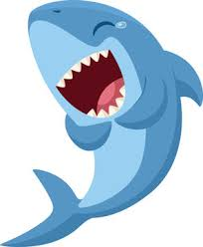

**Team 16:** The Sharks

Lucía Martínez Ruiz [lmrpueyo@bu.edu](mailto:lmrpueyo@bu.edu)

Robert D’Antonio [robdanto@bu.edu](mailto:robdanto@bu.edu)

Xinglin He [hxl@bu.edu](mailto:hxl@bu.edu)

Zhaowen Gu [petergu@bu.edu](mailto:petergu@bu.edu)

Lydia Jacobs-Skolik [ccjs@bu.edu](mailto:ccjs@bu.edu)

Submitted: Mar. 3rd

# 1. Abstract

Since the first prototype test, we have made considerable progress toward our goal of developing an implementation of the SLAM algorithm tailored to underwater robotics. Shortly after the start of the spring 2024 semester, we split our project into separate sub-projects. Robert and Lydia’s work primarily focused on data acquisition and generation, with Robert continuing his work with HoloOcean and Lydia working with real-world sonar data from the Basurelle Sandbanks in the English Channel. Lin and Lydia worked together on developing edge-detection technology to classify artifacts in sonar data that could be used as “landmarks” for the SLAM algorithm. Peter worked on developing the Sonar-SLAM algorithm itself. This report details distinct approaches that will be used to demonstrate the functionality of each of these sub-projects and concludes with a precise plan of how we will combine these sub-projects to produce an implementation of the SLAM algorithm tailored to underwater robotics.

# 2. Required Materials

**2.1.** Hardware:

* Linux PC with Nvidia Tesla V100 GPU and OpenGL installed
* Generic PC (preferably Windows)

**2.2.** Software:

* Python 3.0 libraries
  + HoloOcean (and its dependencies)
  + OpenCV
  + NumPy
  + matplotlib
  + seaborn
  + Pandas
  + pyxtf
* C++ libraries
  + OpenCV: >= 3.0
  + boost
* Cmake: >= 2.8
* Visual Studio: >= 2015
* VMware workstation pro >= 17
* ImageJforXTF

# 3. Set Up

As our project is entirely in software, most of these tests can be performed on any PC as long as all required packages and libraries are installed and accessible. The exception is the HoloOcean underwater simulator, which (from our experience) requires a Linux system with a Nvidia Tesla V100 GPU. Today, we will use a V100 GPU available on the BU SCC. For Blue-rov slam, the program is really unstable due to the publisher’s predilection in using Python instead of C++ for ROS. It may have stack errors from time to time.

# 4. Pre-Testing Setup Procedures

**4.1.** Holoocean:

1. Connect to a desktop on BU’s SCC with a V100 GPU
2. Run the following commands to prepare HoloOcean:
   * cd /projectnb/ece601/SlamSeniorProj2023/HoloOcean_scripts
   * source startHolo.sh
3. Run HoloOcean files using python <<filename>>
   * Primary working file: nav_agent.py

**4.2.** Basurelle Sandbanks

1. Download ReadSonar.py from <https://github.com/peterguzw0927/Senior_Design>
2. Install the ImageJforXTF from <https://sourceforge.net/projects/imagejforxtf/>
3. Download the sandbank datasets: <https://data.europa.eu/data/datasets/processed-side-scan-sonar-data-from-bassurelle-sandbanks-sci?locale=en>

**4.3.** Edge Detection

1. Download the zip file or git clone this repository: <https://github.com/hxl1236/Edge-detection.git>
2. Extract the files from the zip folder.

**4.4.** SonarSLAM Algorithm

1. Open VMware workstation pro 17
   * Power up virtual machine

# 5. Testing Procedure

**5.1.** HoloOcean:

1. Run nav_agent.py, which tests the HoloOcean side-scan sonar simulation on a vehicle with a lawnmower navigation path
2. Run log_read.py, which reads the log file written by nav_agent.py

**5.2.** Basurelle Sandbanks

1. Run ReadSonar.py in the terminal, which reads one of the xtf files from the sandbanks datasets.
2. Open ImageJforXTF and use it to read the same xtf file.
3. Both files will produce the same sonar images for comparison.
4. Both files also read all the information stored in each ping of the image.

**5.3.** Edge Detection

1. In the terminal:
   * cd to the path containing all these Python files with corresponding images.
   * Run python testingCurlyTorpedo.py
   * Run python testingWholeImg.py
   * Run python testingCutWhole1.py
   * Run python testingCutWhole2.py
2. Each of the codes tests on a different sonar image and produces a final filtered image, highlighting the contours of detected landmarks.

**5.4.** SLAM Algorithm

1. Open up a new terminal
   * cd ws_sonar/
   * catkin build
   * bash s1_run.bash
2. Open up a new terminal
   * cd ws_sonar/
   * bash s2_run.bash
3. Download image and save data after completion

# 6. Measurable Criteria

**6.1.** Holoocean

1. Produces a reasonable and usable output that can be deciphered into an image using the log_read.py utility program

**6.2.** Basurelle Sandbanks

1. The code should be able to read a .xtf file and generate a sonar image.
2. It will show you the information (such as pitch, roll, depth, x, and y coordinates) of one ping.
3. The sonar image generated by the code should match the image generated by ImageJforXTF.

**6.3.** Edge Detection

1. It should be able to filter out noises (such as debris) on the sonar images.
2. Identify large landmarks (torpedo) on sonar images with a success rate >= 70%.
3. Output the number of landmarks on sonar images.

**6.4.** SLAM Algorithm

1. Run the program multiple times and compare the final results.
2. Did the program work?
3. Is the point cloud similar?
4. Is the trajectory constant?

# 

# 7. Test Results

**7.1.** HoloOcean

**7.2.** Basurelle Sandbanks

**7.3.** Edge Detection

The edge detection algorithm works such way that, once received the images collected by the robot, the first detection focuses on the dark areas in the land, then the bright zones that are usually torpedos, and finally it ensembles both the dark and the bright ones in a clear landmark. Therefore, the aim is focusing on detecting the center of the determined ensembled landmark. In the following section there can be seen four different outputs from the Testing Day.

First Image:

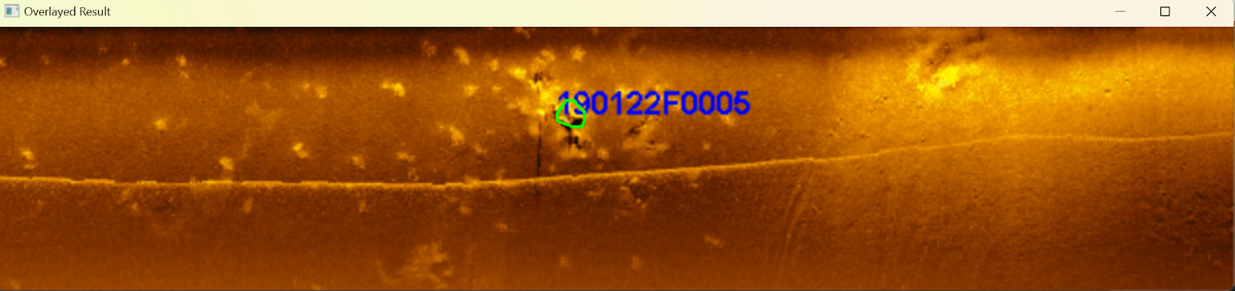In this first image we can see the detection of an encountered landmark. The number indicates that it is a founded torpedo by the human eye, and we wanted to see if the algorithm can detect it.

A 100% success can be clearly recognized.

Second Image:

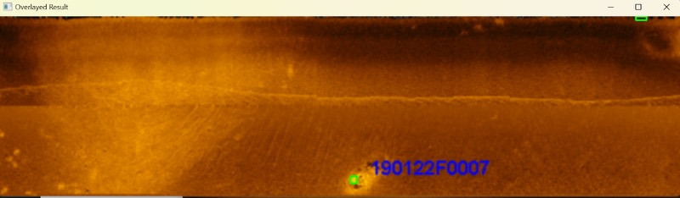It is similar to the first image, and another 100% success is given. In this image the center detection explained previously is perfectly defined.

Third Image:

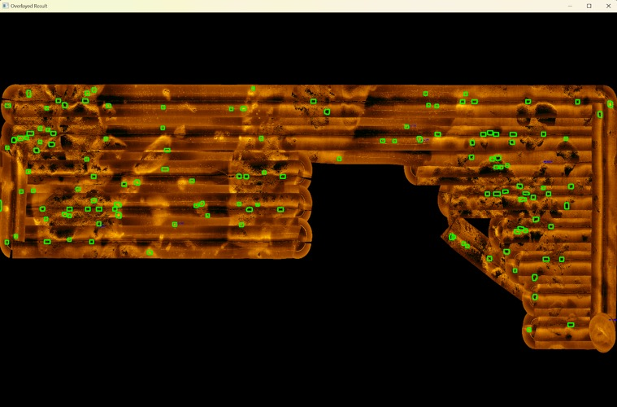This third output represents a whole path that the robot makes. The aim is to proof if the algorithm is able to detect all the landmarks in bigger dimensions. Despite the accuracy is worse, the algorithm demonstrates that it can work with huge paths.

Fourth Image:

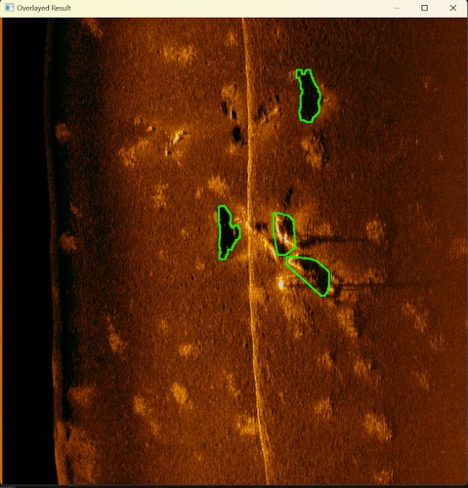

This last image outputs a clear 100% success in the detection of all the dark landmarks and bright torpedos.

**7.4.** SLAM Algorithm

# 8. Test Conclusions

**8.1.** HoloOcean

* This round of testing showcases the limit of HoloOcean when it comes to accomplishing our goal of data acquisition. While there is still significant potential from this program, poor documentation, a lack of online examples, and long runtimes have led to very slow productivity. A reasonable next step—and one we will take—is to reach out to the Frost Lab at Brigham-Young University, which is responsible for development and maintenance of the HoloOcean simulator. Ideally, they will be able to provide suggestions for how we can effectively and efficiently construct a simulation file to acquire the necessary data for our project.

**8.2.** Basurelle Sandbanks

* Since we are now able to read a .xtf file from the sandbank dataset and produce actual sonar images, we can use it to generate more sonar images to test the edge detection algorithm. Also, by obtaining the position information from the .xtf file, it won’t be too complicated to sort the sonar images based on the coordinates and draw the entire trajectory of the vehicle.

**8.3.** Edge Detection

* The current edge detection algorithm is reliable because it can successfully detect the correct landmarks on multiple sonar images. By incorporating this algorithm with the sonar images and position coordinates of the vehicle extracted from the sonar dataset, we should be able to generate a global map storing both the locations of the landmarks and the vehicle. Then, we could develop a landmark-matching algorithm that can match the shapes of similar landmarks when the vehicle revisits the same location. If the landmarks are matched, we can perform loop closure to improve the accuracy of the vehicle’s trajectory.

**8.4.** SLAM Algorithm

* The Blue-rov is not so stable when deploying in the virtual machine, but the effect of the slam algorithm way precedes the ORB3-SLAM since all of its data has two sources, one from the imaging sonar’s feature extraction node and the other from the dead reckoning node. The slam algorithm combines both inputs and runs through a very sophisticated loop detection algorithm, and mapping algorithm and finally comes up with a precision measure of the trajectory and landmarks. (Figure 1.)

**9. Appendix**

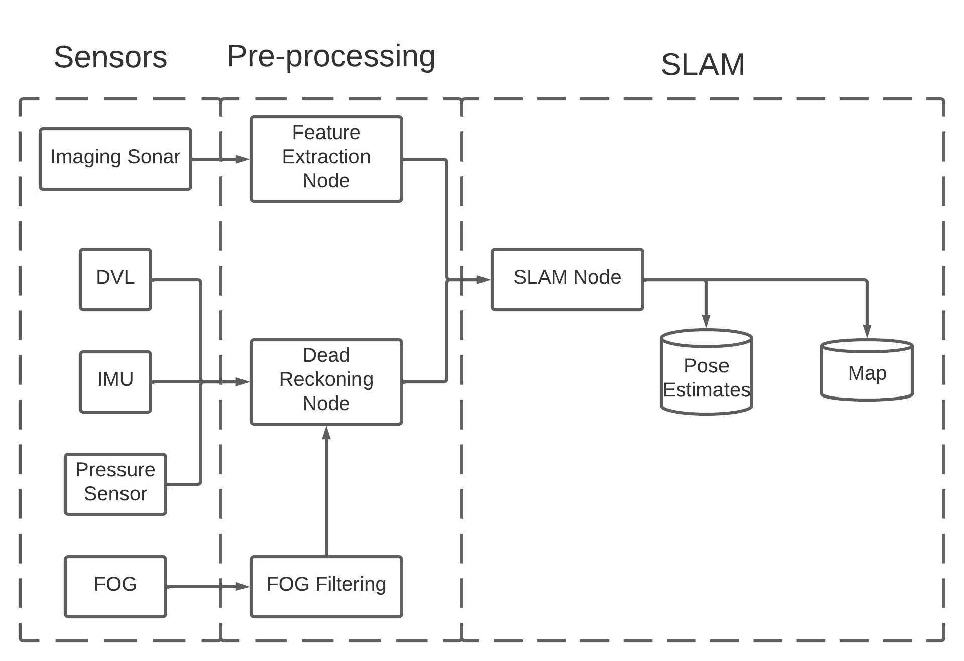

**Fig. 1.** SLAM overview